# Azure Implementing backup

## **Tutorial**

In this tutorial, we will backup an Azure VM and restore deleted data from the backup:

### **BackUp VM**

1. **Create a Resource group**:

**$ az group create -n aztutorial -l uksouth**

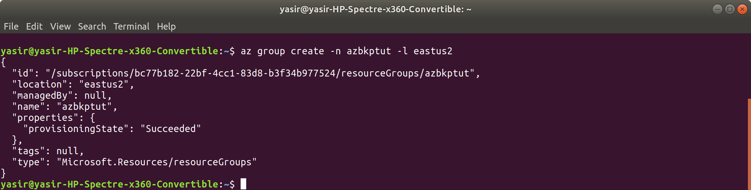

1. **Create a VM**:

**$ az vm create -g aztutorial -n azbackupvm -l uksouth --image UbuntuLTS --generate-ssh-keys**

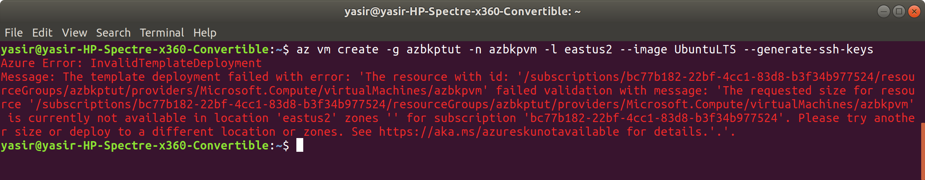

**created using Azure Portal**

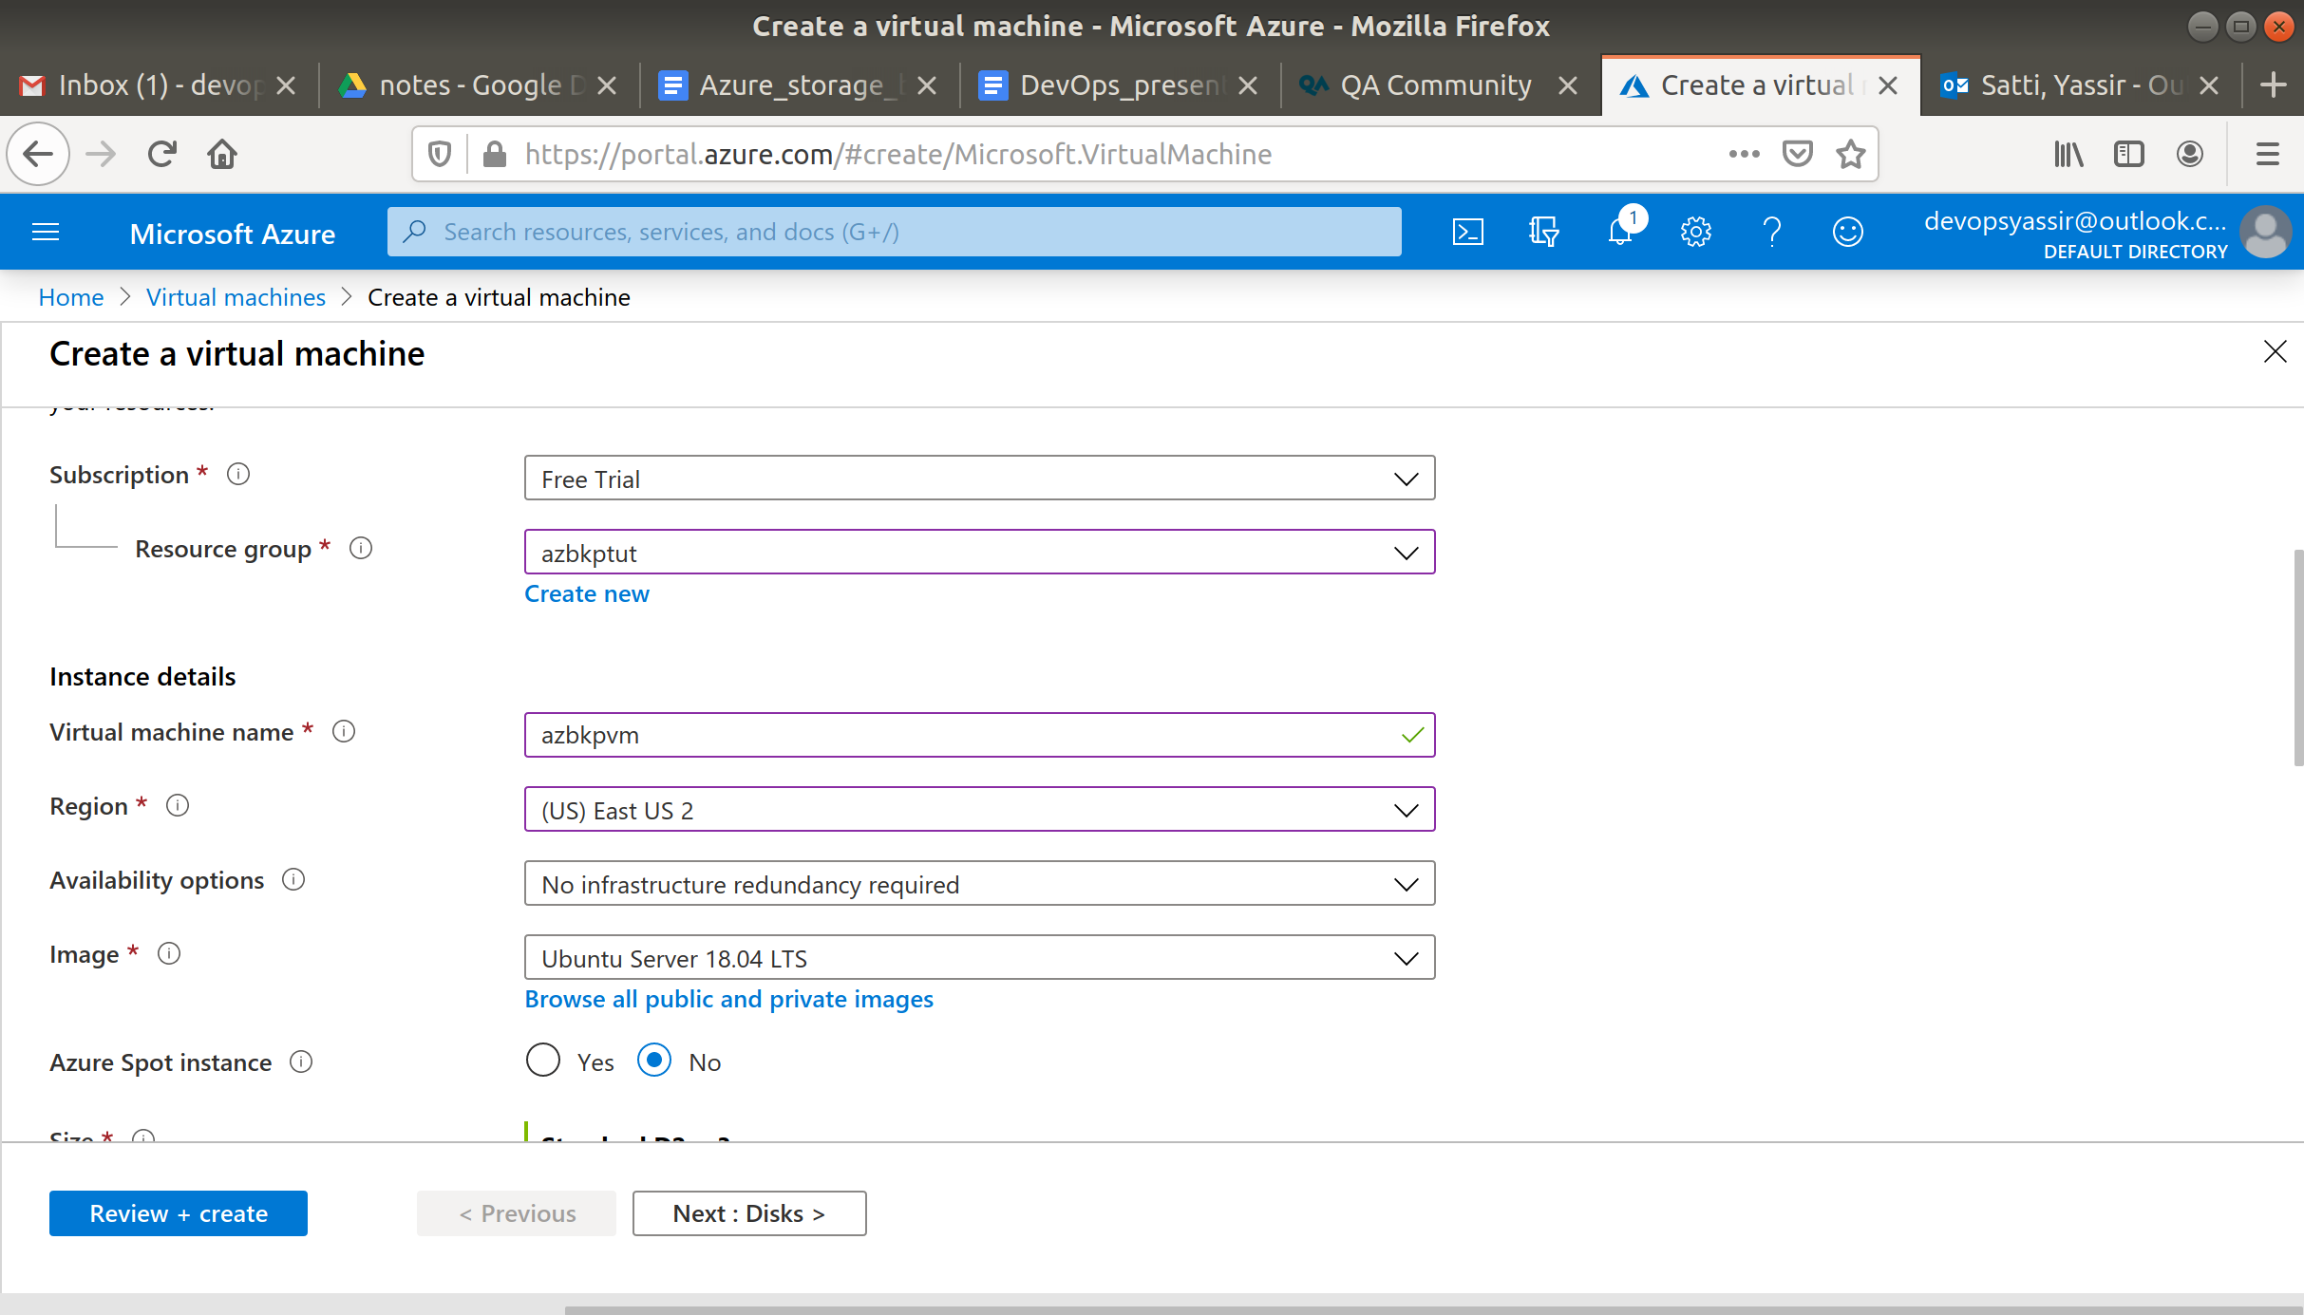

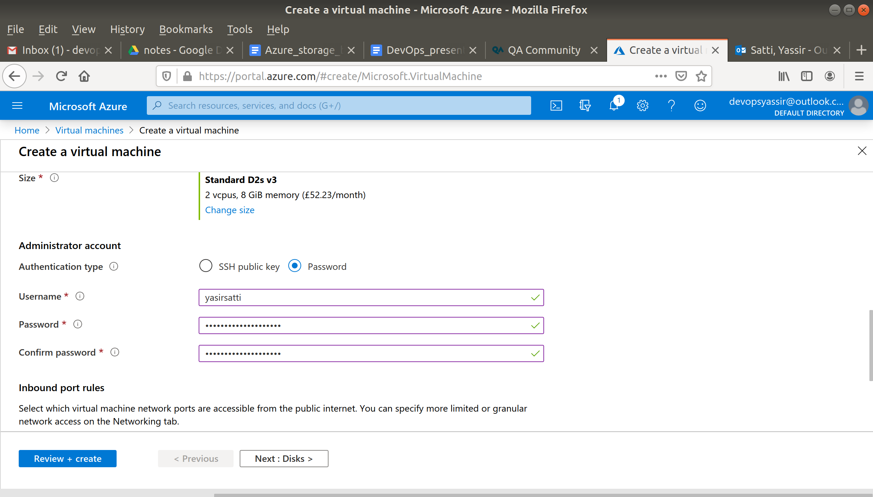

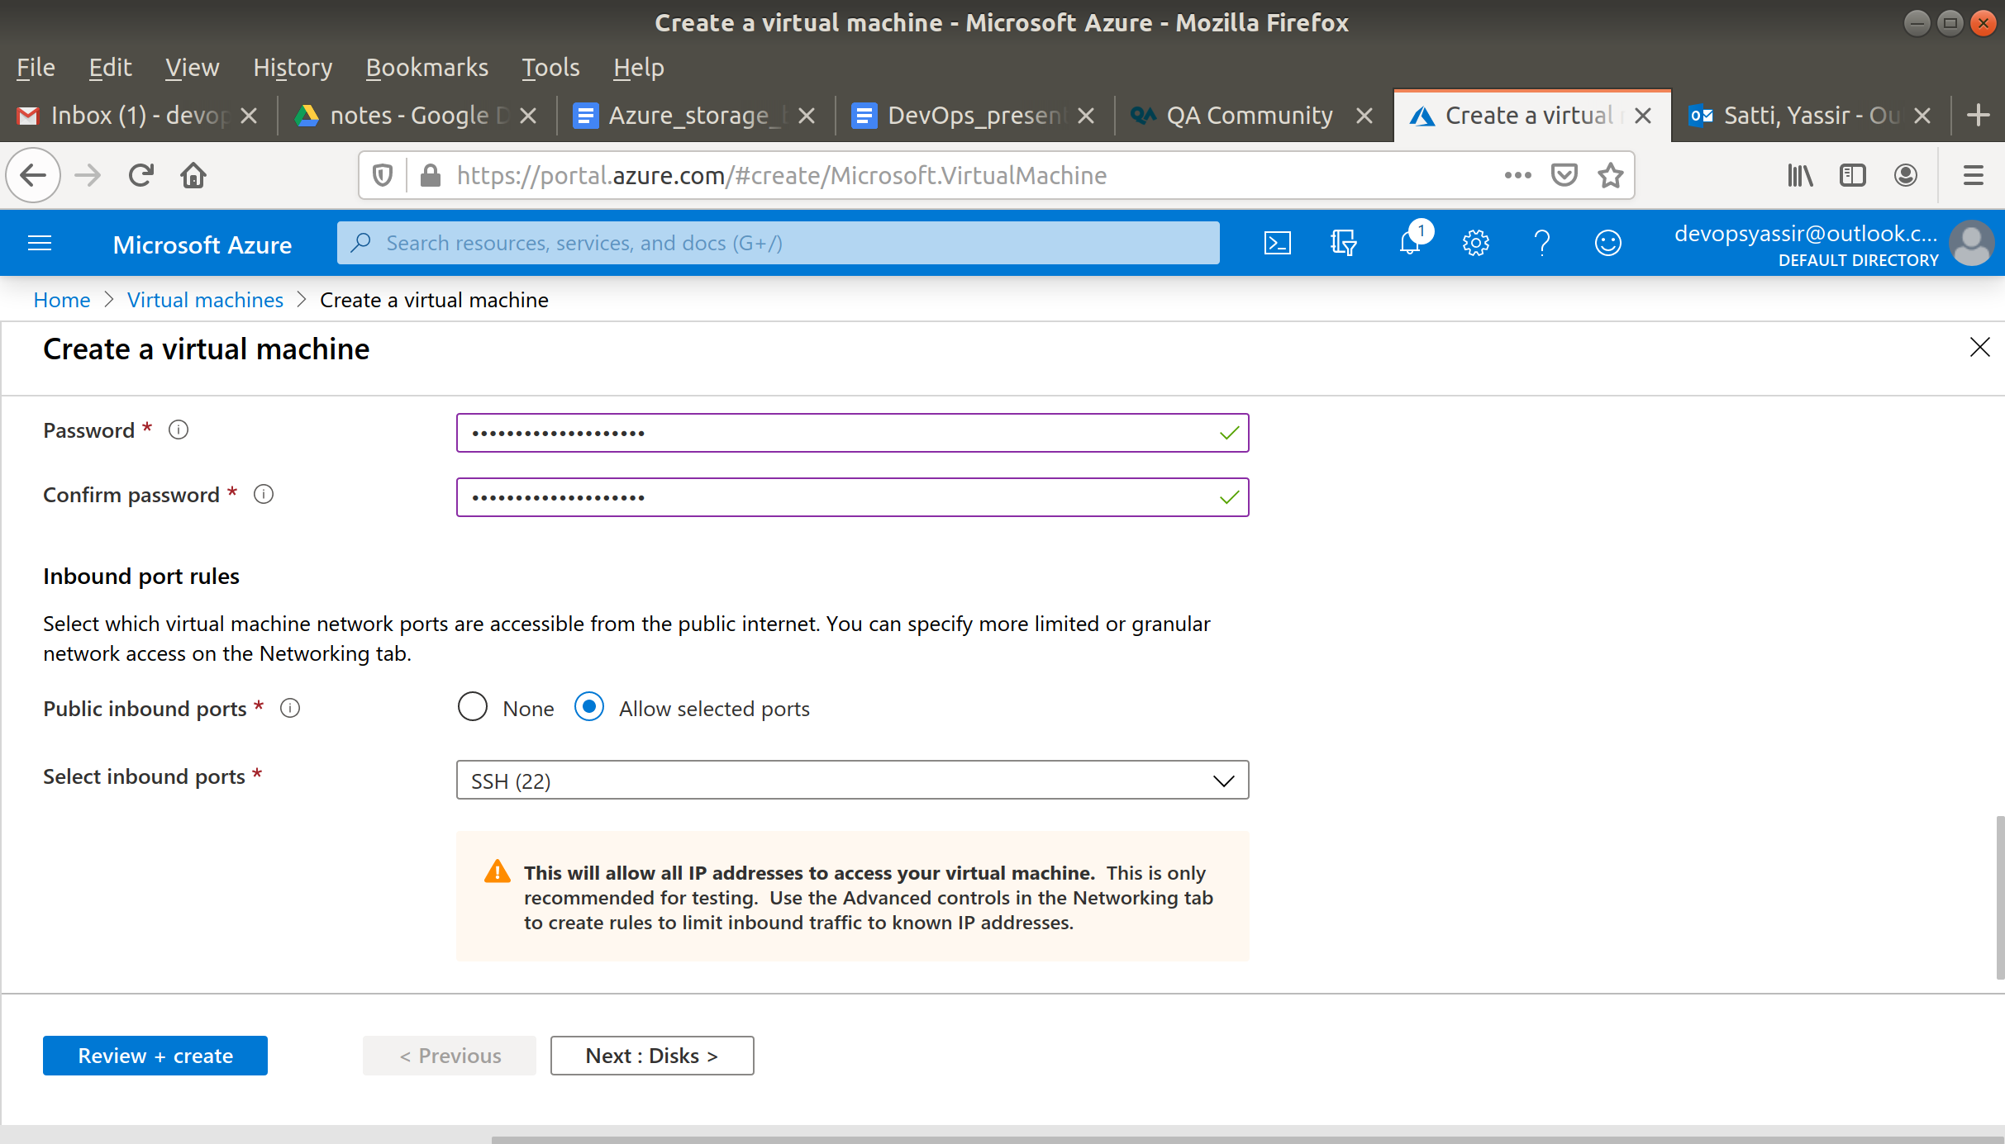

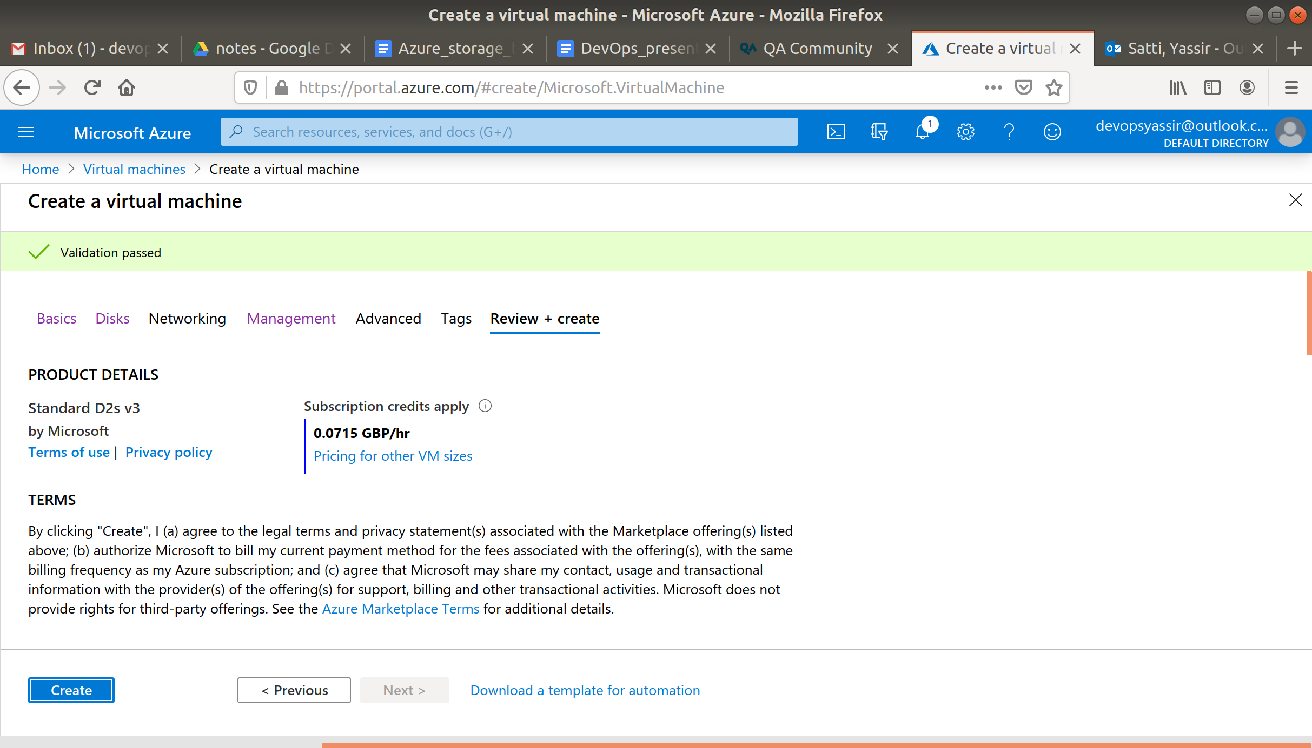

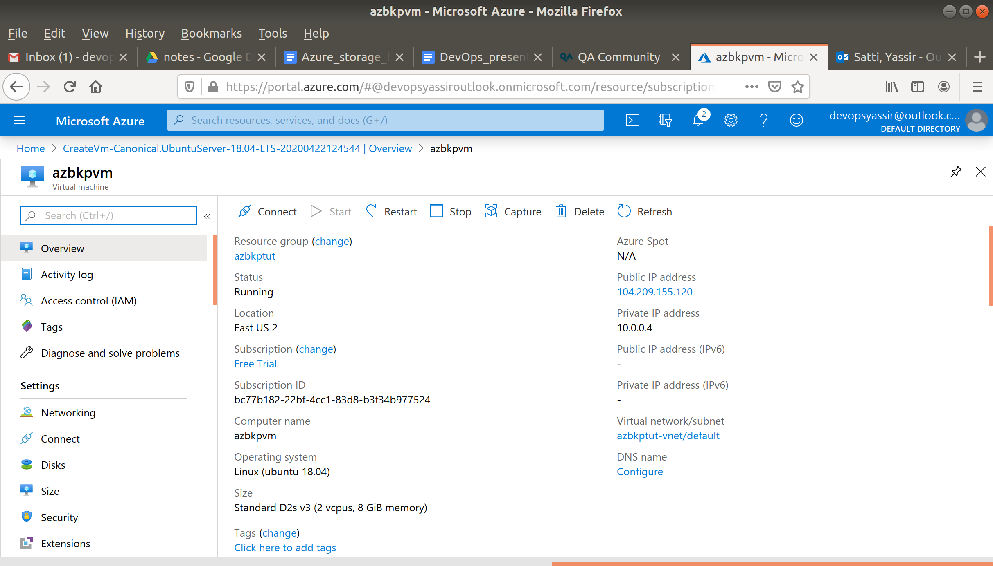

1. **Obtain the public IP of your VM**:

**$ az vm show -g aztutorial -n azbackupvm -d --query [publicIps] -o table**

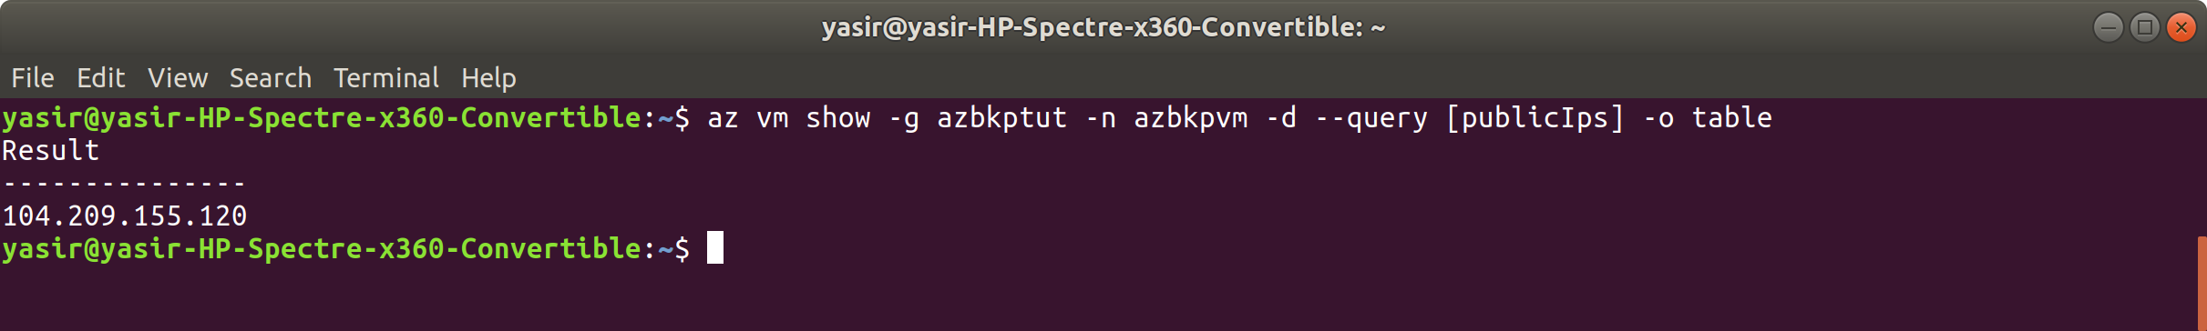

1. **SSH onto your VM, create a couple of new files and then Exit out of the VM**:

**$ ssh <publicip>**

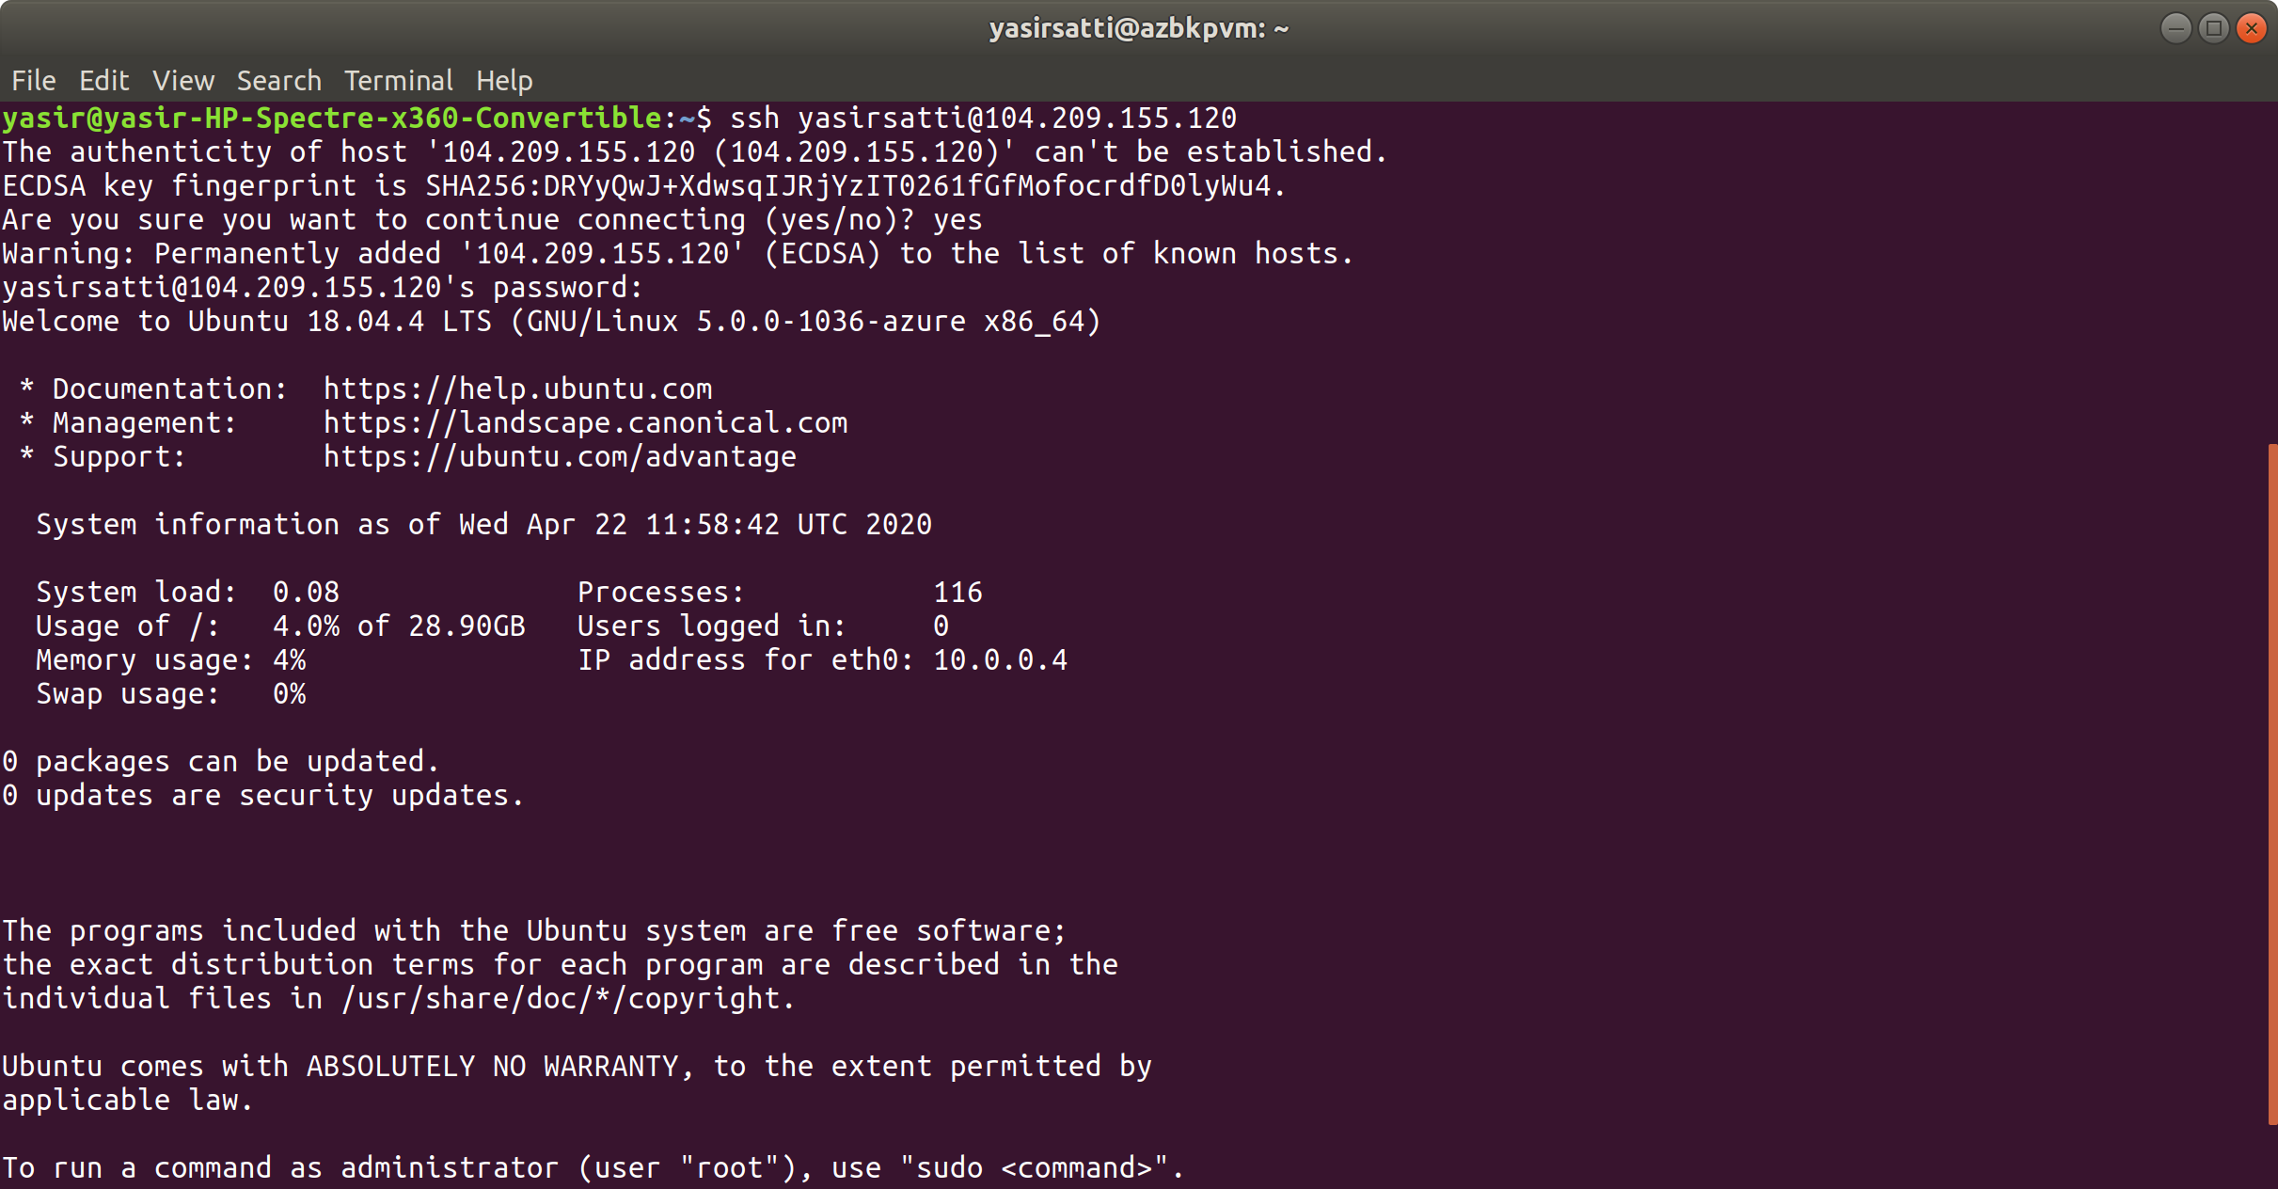

You may need to enter "yes" in the terminal at this point.

**$ cd**

**$ touch file1.txt file2.txt file3.txt**

**$ exit**

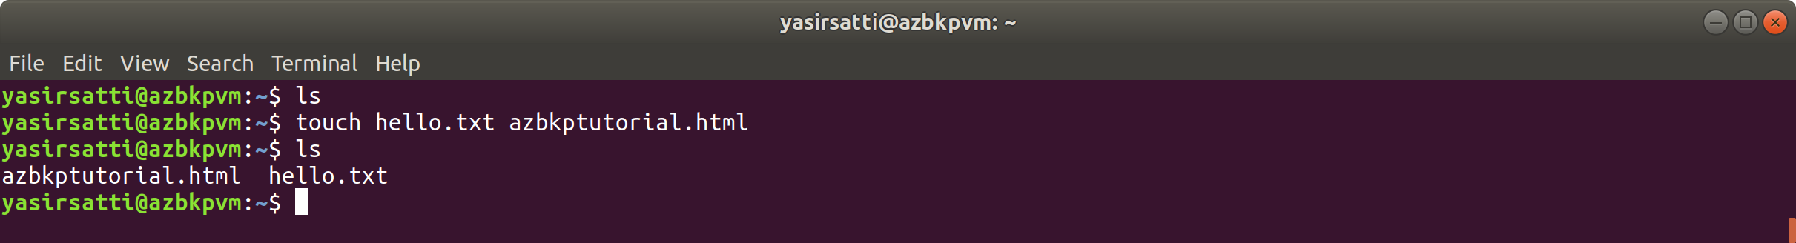

1. **Create a Recovery Services Vault**:

**$ az backup vault create -g aztutorial -n aztutvault -l uksouth**

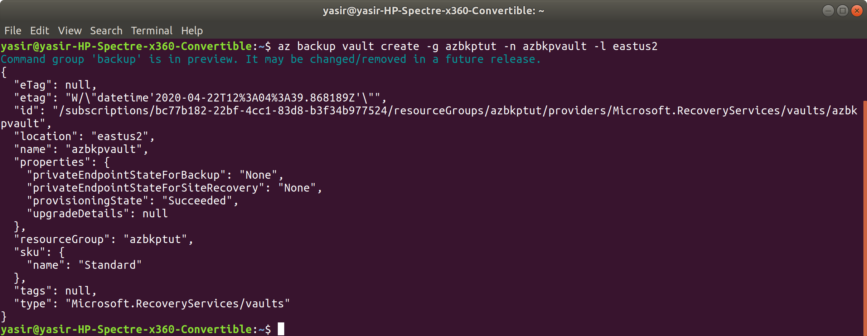

1. **Enable Backup for Azure VM**:

**$ az backup protection enable-for-vm -g aztutorial --vault-name aztutvault --vm azbackupvm --policy-name DefaultPolicy**

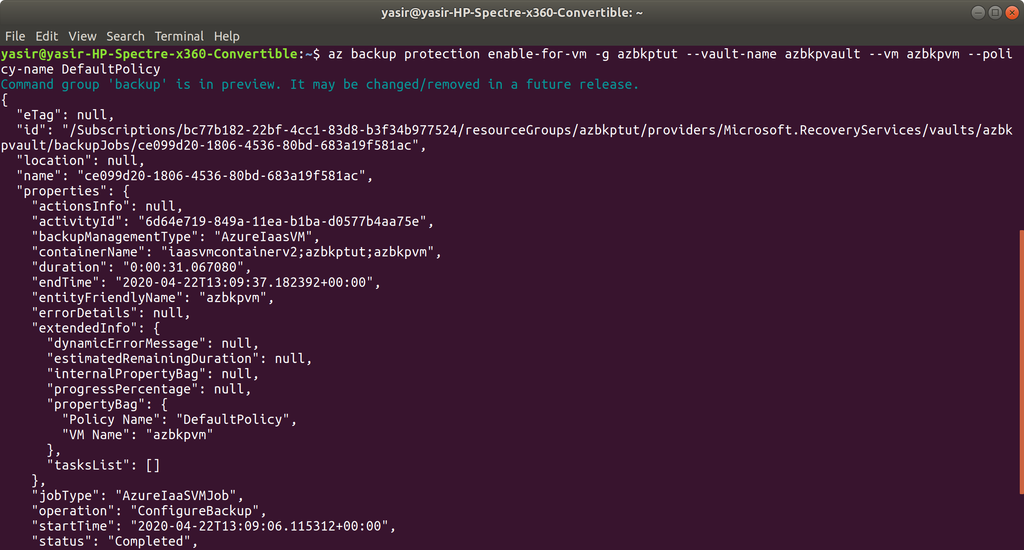

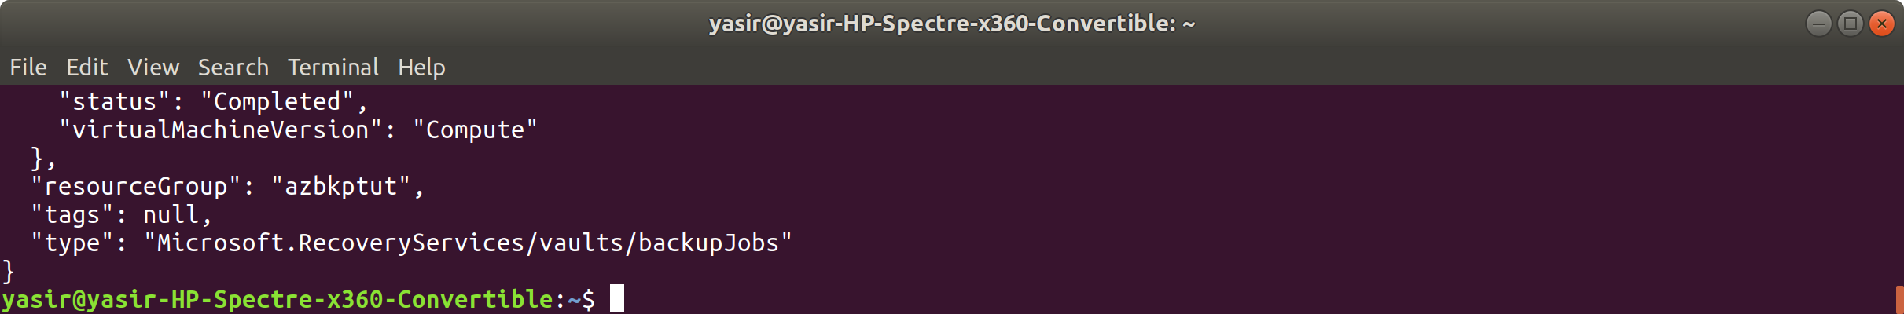

1. **Manually start a Backup Job**:

**$ az backup protection backup-now -g aztutorial --vault-name aztutvault --container-name azbackupvm --item-name azbackupvm --backup-management-type AzureIaasVM --retain-until 30-01-2020**

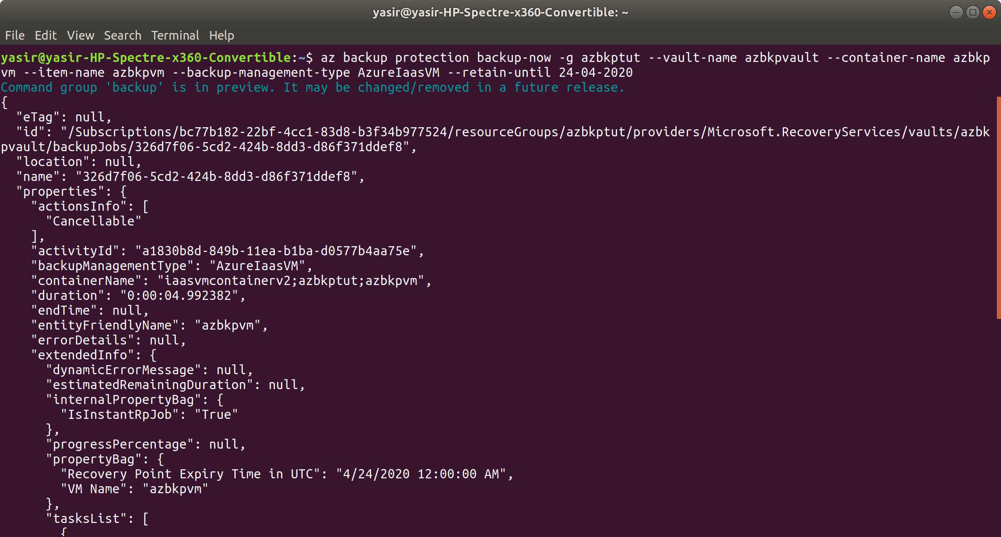

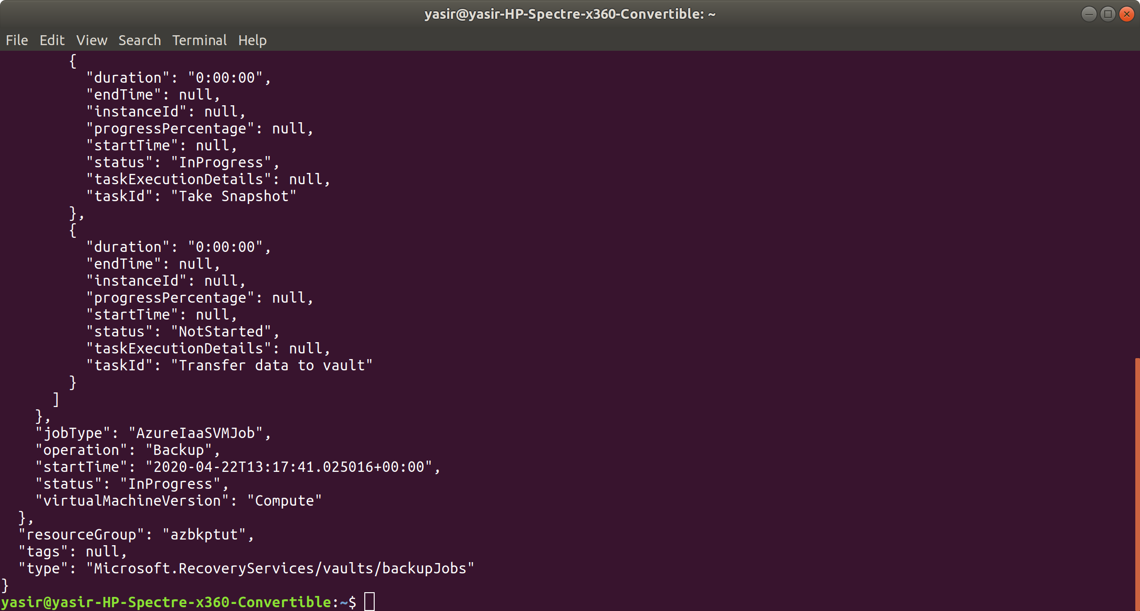

You will need to amend the --retain-until flag to reflect a date after the current date!

1. **Monitor the Backup Job**:

**$ az backup job list -g aztutorial --vault-name aztutvault -o table**

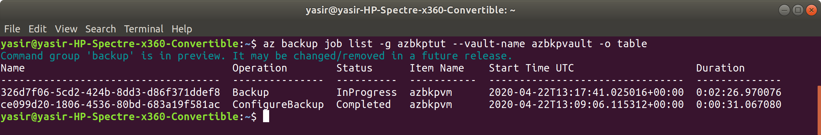

When the Status of the Backup Job reports Completed, your VM is protected with Recovery Services and has a full recovery point stored!

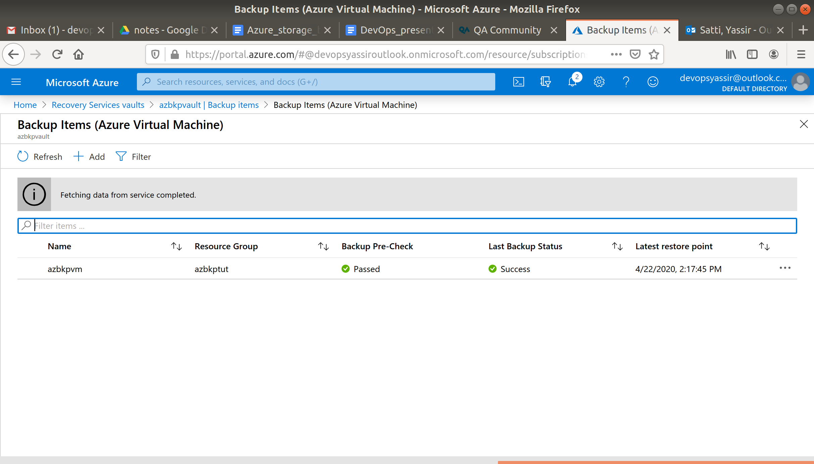

### **Restore Data**

1. **SSH onto your VM and delete the files we made earlier**:

ssh <publicip>

cd

rm file1.txt file2.txt file3.txt

exit

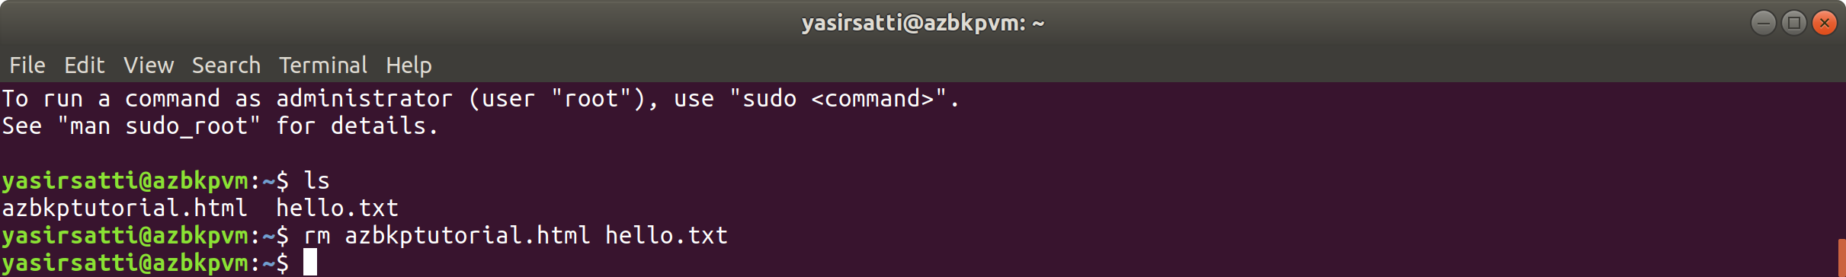

To restore your files, Azure Backup **provides a script to run on your VM that connects your recovery point as a local drive**.

You can browse this local drive, restore files to the VM itself, then disconnect the recovery point.

1. **Select the most recent Recovery Point to use (this should be the backup you just manually created)**:

**$ az backup recoverypoint list -g aztutorial --vault-name aztutvault --container-name azbackupvm --item-name azbackupvm --backup-management-type AzureIaasVM --query [0].name -o table**

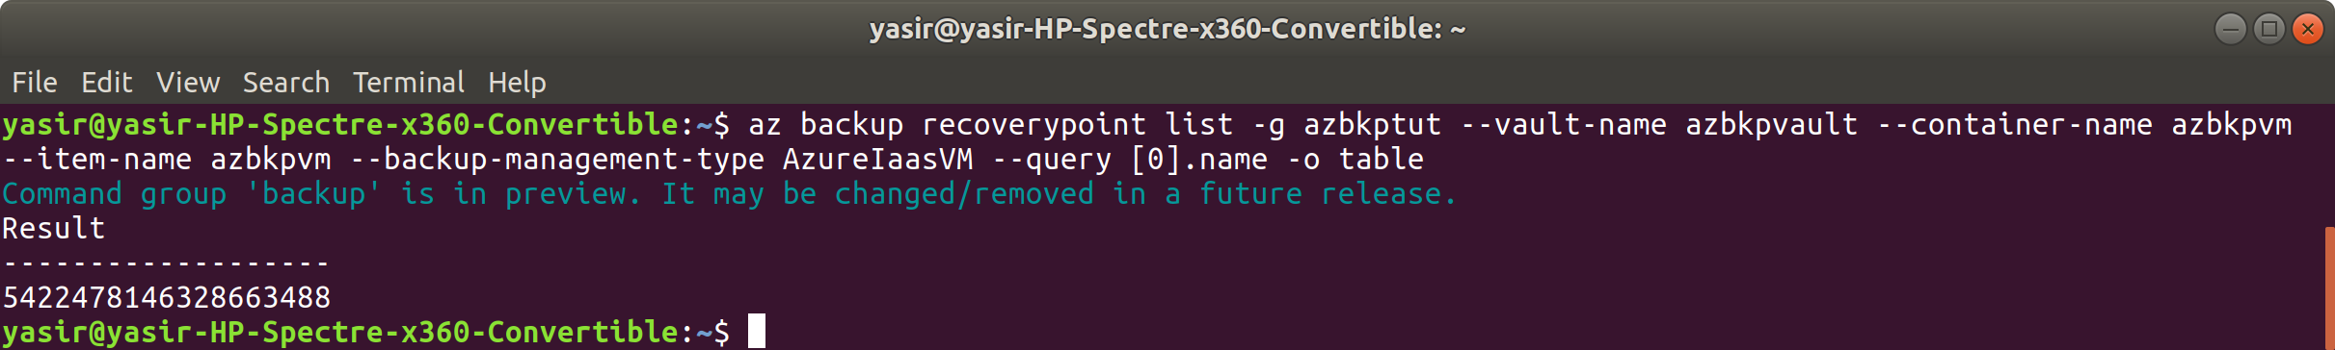

**5422478146328663488**

1. **Get the script that connects the recovery point to your VM**:

**$ az backup restore files mount-rp -g aztutorial --vault-name aztutvault --container-name azbackupvm --item-name azbackupvm --rp-name <RecoveryPointName>**

Replace <RecoveryPointName> with the name of the recovery point that you obtained in the previous command.

The script is downloaded and a password is displayed!

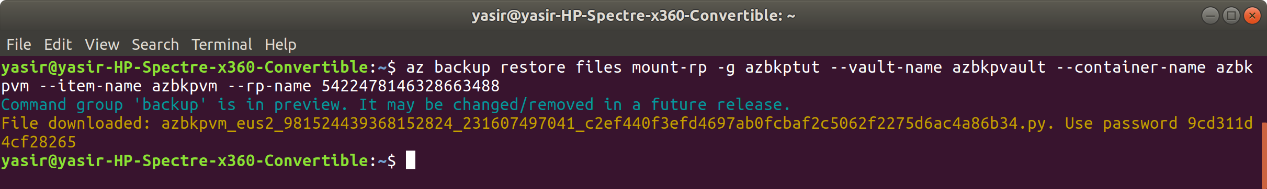

azbkpvm_eus2_981524439368152824_231607497041_c2ef440f3efd4697ab0fcbaf2c5062f2275d6ac4a86b34.py

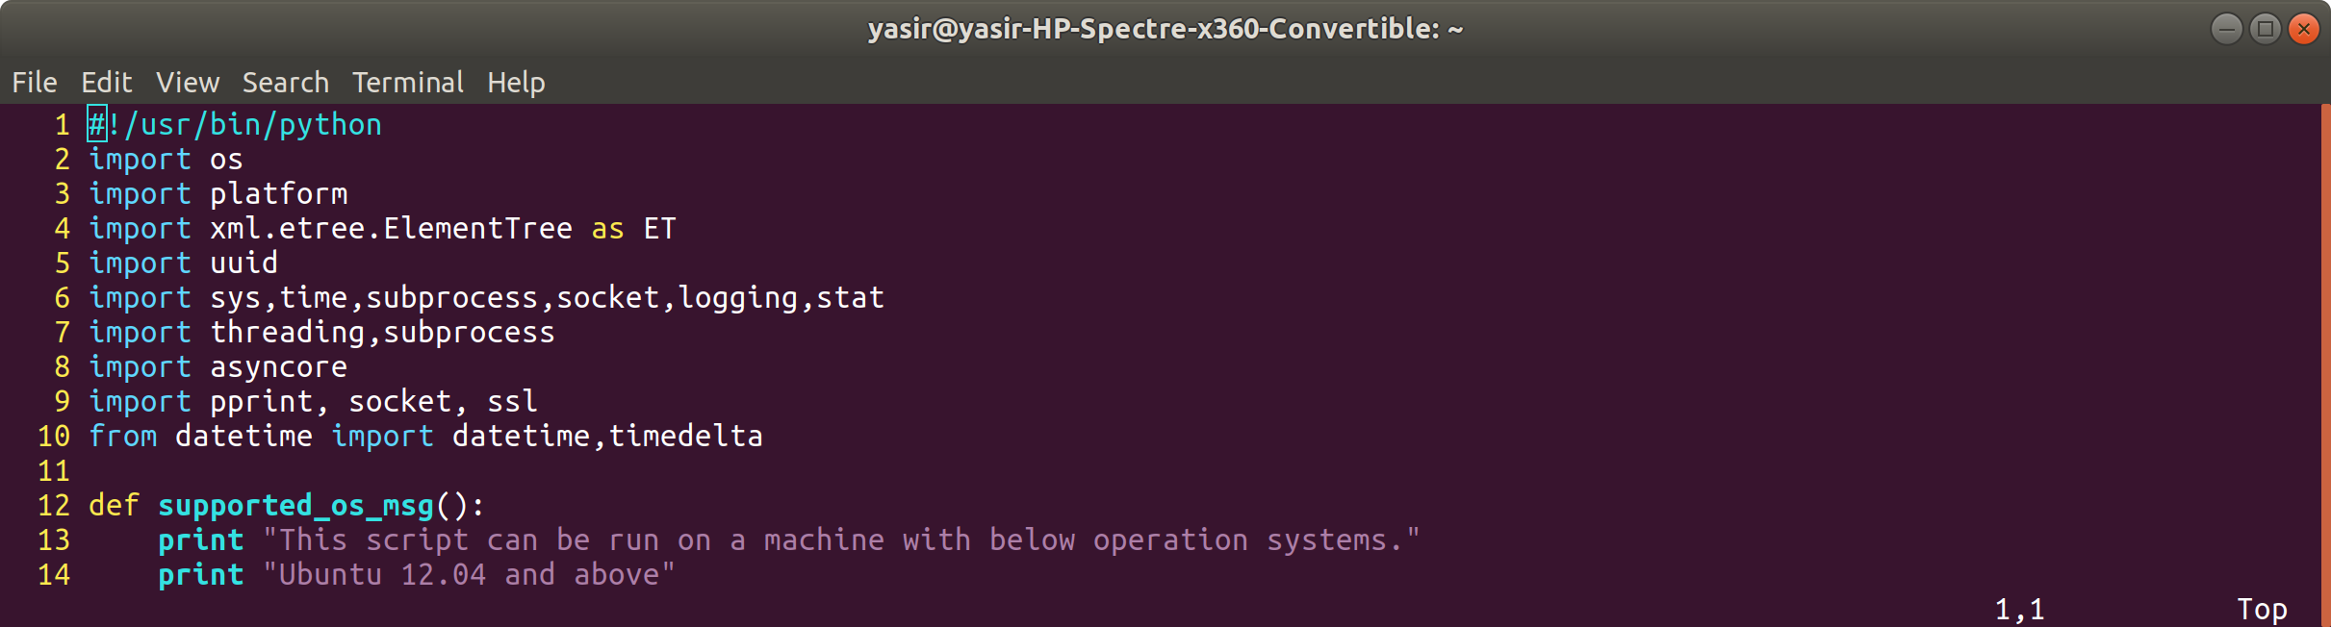

password: 9cd311d4cf28265

1. **Transfer the script to your VM**:

scp <scriptname> <publicip>:

replace <scriptname> with the name of the script you obtained from the previous command, and replace <publicip> with your VM's public IP address.

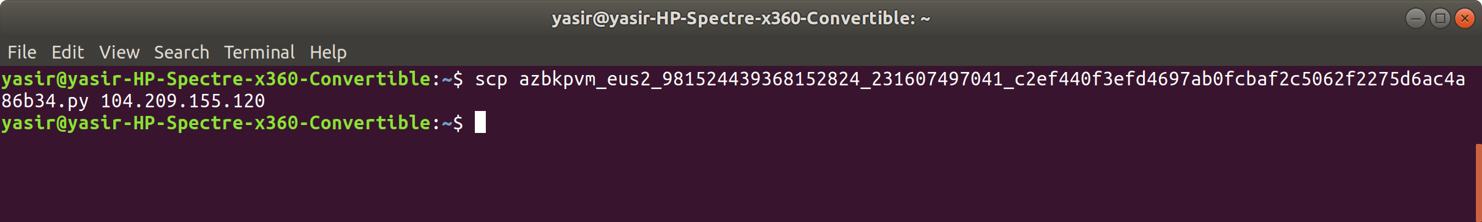

scp commands did not work, so I did the following:

$ cat azbkpvm_eus2_981524439368152824_231607497041_c2ef440f3efd4697ab0fcbaf2c5062f2275d6ac4a86b34.py

the highlighted the file content on the screen and copied it

then

**$ ssh <publicip>**

**$ vim file**

pasted the content into the file saved

**$ mv file azbkpvm_eus2_981524439368152824_231607497041_c2ef440f3efd4697ab0fcbaf2c5062f2275d6ac4a86b34.py**

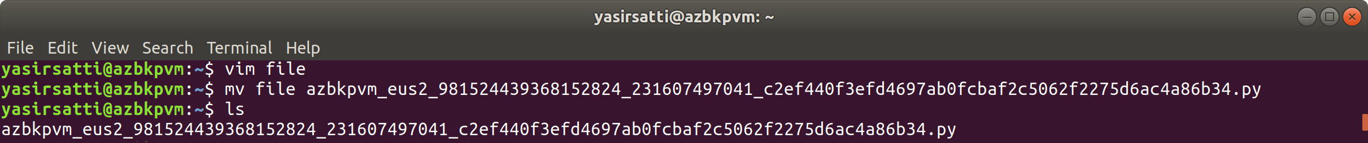

1. **Connect to your VM and run the script**:

**$ ssh <publicip>**

**$ chmod +x <scriptname>**

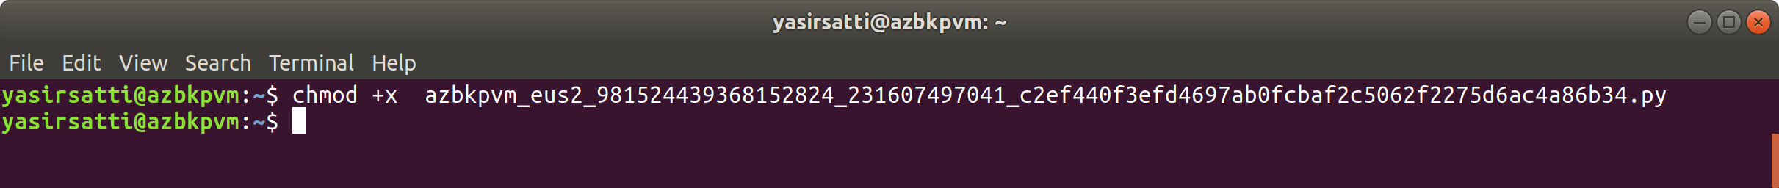

**$ ./<scriptname>**

You will be prompted to enter a password at some point. Enter the password you obtained from step 3.

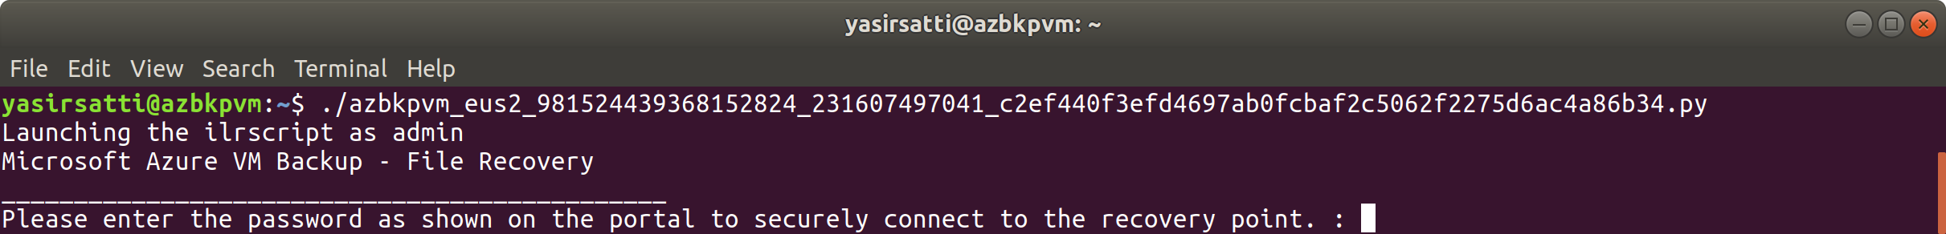

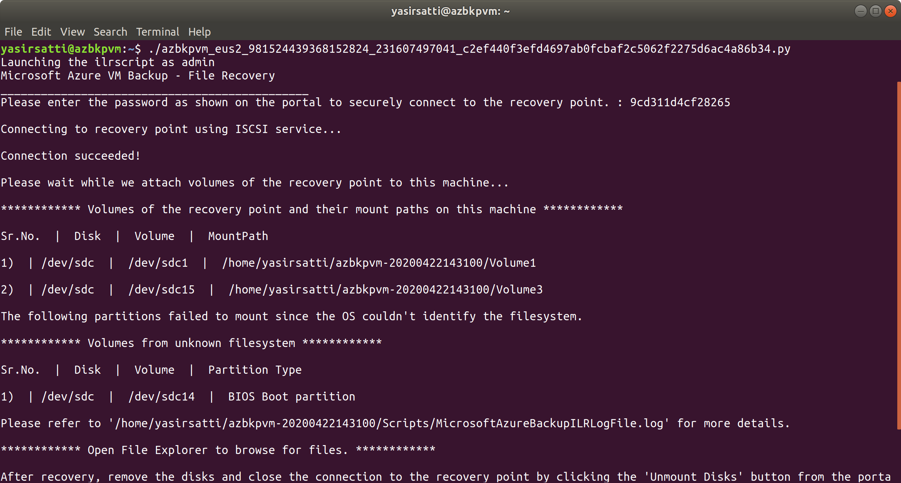

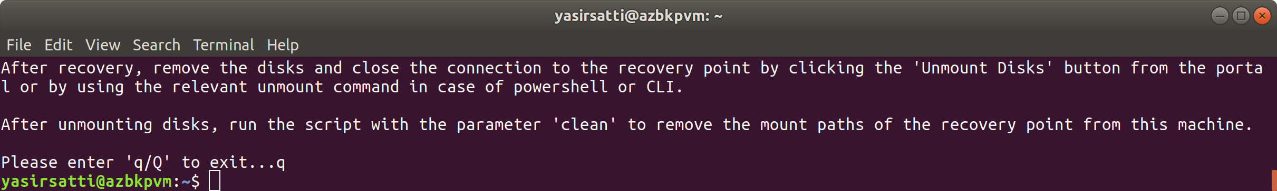

The output from the script gives you the path for the recovery point.

1. **Restore the deleted files**:

sudo cp <recoverypath>/file1 ~

sudo cp <recoverypath>/file2 ~

sudo cp <recoverypath>/file3 ~

You will need to use the recovery path given in the output of the previous command. The full path usually looks something similar to:

<recoverypath>/Volume1/home/jay/file.txt

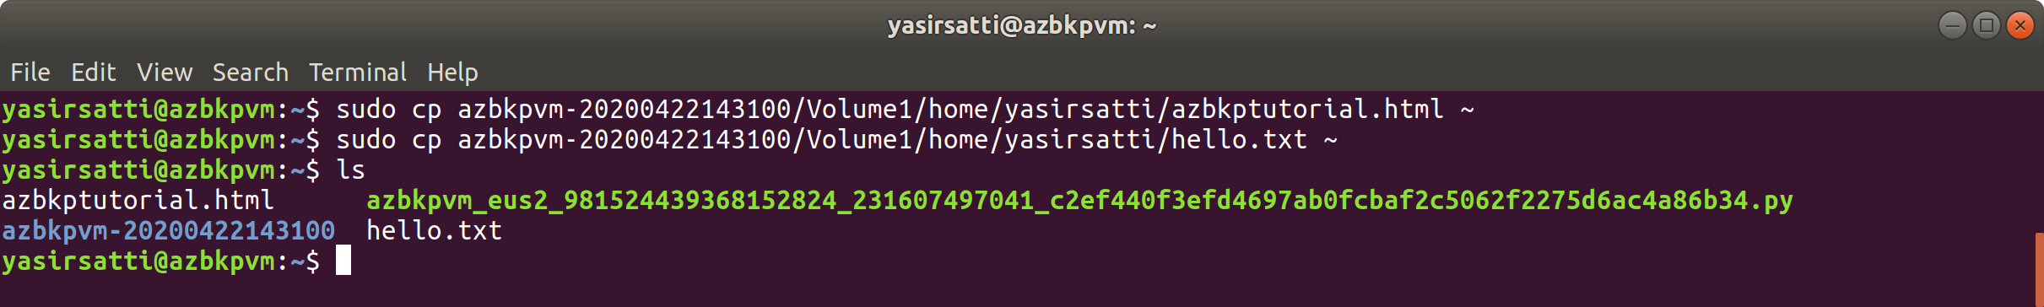

1. **Check the files have been restored**:

ls -l

exit

1. **Unmount the Recovery Point from your VM**:

**$ az backup restore files unmount-rp -g aztutorial --vault-name aztutvault --container-name azbackupvm --item-name azbackupvm --rp-name <RecoveryPointName>**

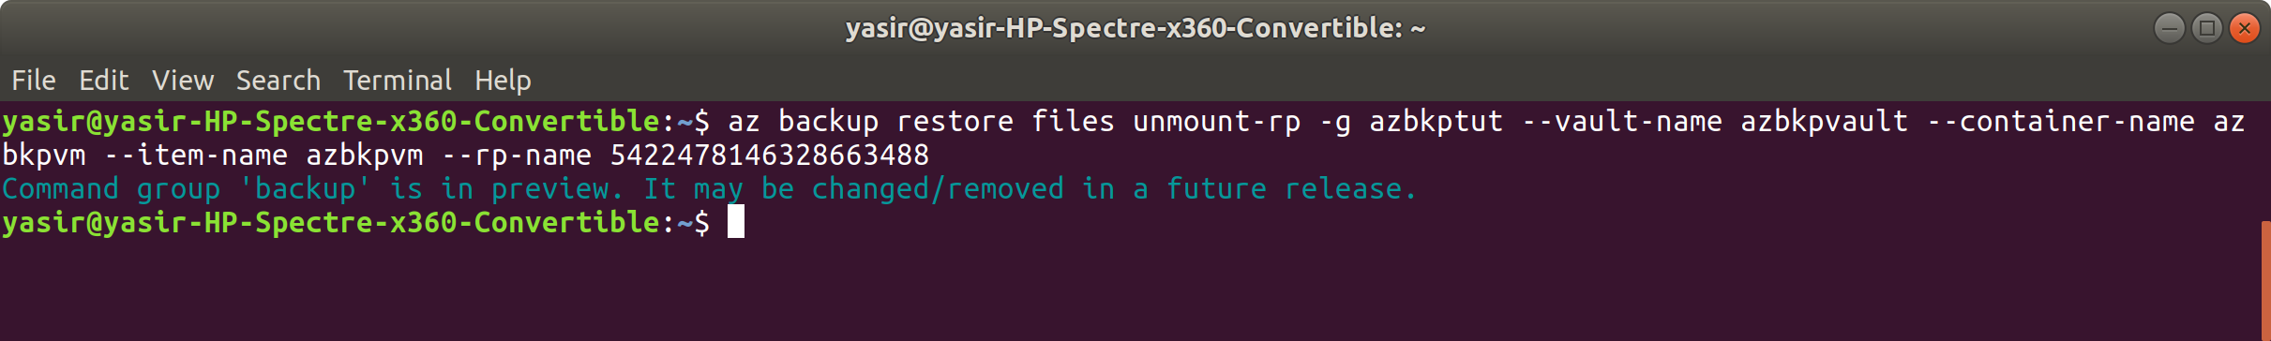

**And, you're done!**

### **Clean up**

1. **Delete the resource group**:

**$ az group delete -n aztutorial -y --no-wait**

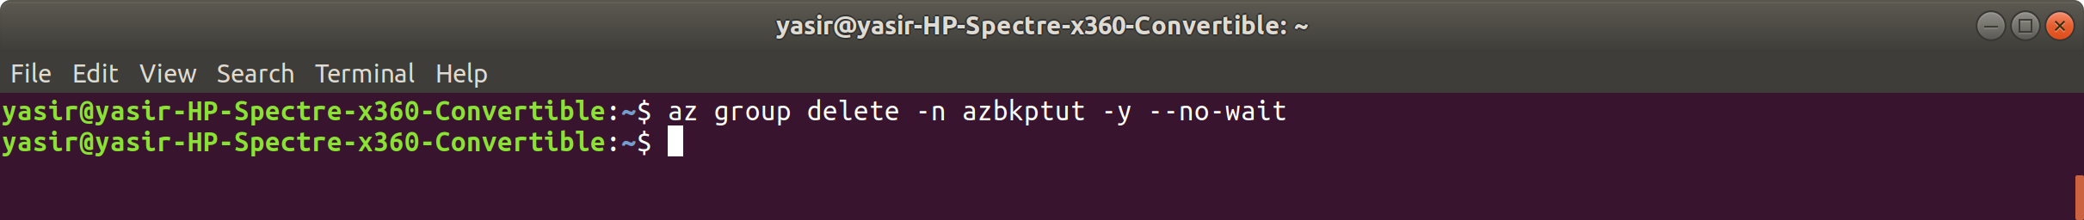

1. **Delete the script**:

**$ rm <scriptname>**

